**The West Brookfield Historical Commission**

and the Community

with Support from The Trustees

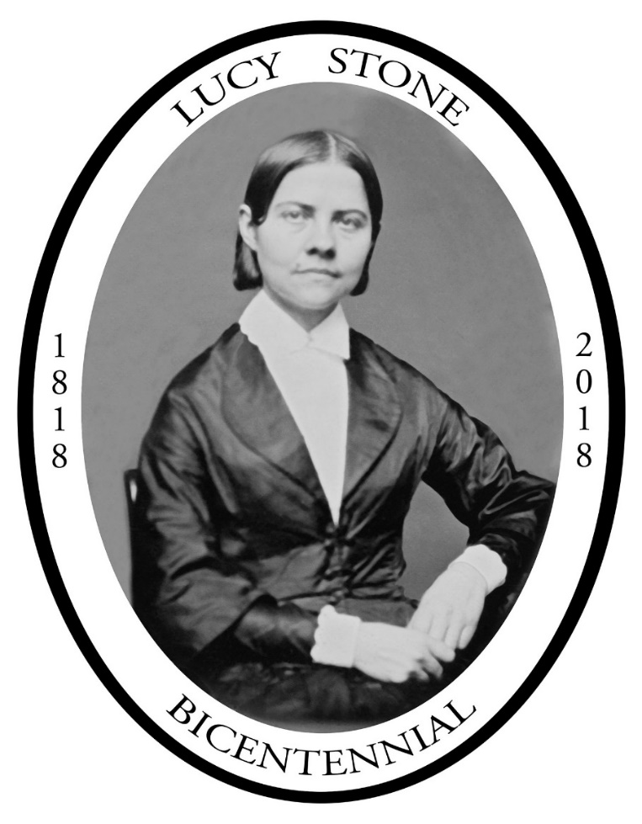present a

Bicentennial Celebration

Saturday & Sunday

August 11 & 12, 2018

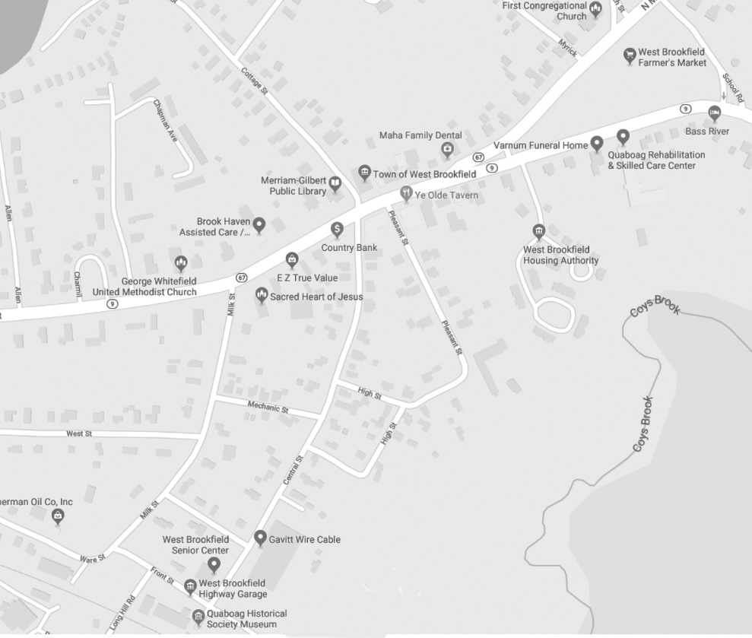 **C**

**B**

**A**

The Venues of the

Lucy Stone Bicentennial Celebration

A = Quaboag Historical Society Museum, Saturday Parking

B = Town Hall

C = First Congregational Church

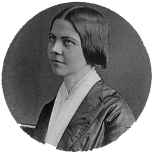

**Dedication**

This Celebration of the birth and legacy of Lucy Stone is dedicated to all those who have worked to achieve equal rights for women and those who continue to do so now and in the future.

“*Now all we need is to continue to speak the truth fearlessly, and we shall add to our number those who will turn the scale to the side of equal and full justice in all things.”*

Lucy Stone

** The Trustees of Reservations**

is proud to support

The West Brookfield Historical Commission

And the Community

in their Lucy Stone Bicentennial Celebration.

*Our Mission* - "The Trustees of Reservations preserve, for public use and enjoyment, properties of exceptional scenic, historic, and ecological value in Massachusetts."

*Who We Are* - We are more than 100,000 people like you who love the outdoors, who love the distinctive charms of New England, and who believe in celebrating and protecting them, for everyone, forever.

Together with our neighbors, we protect the distinct character of our communities and inspire a commitment to our special places. Our passion is to share with everyone the irreplaceable natural and cultural treasures we care for.

*What We Do* - We enjoy and care for more than 100 special places – nearly 25,000 acres – all around Massachusetts. And we are actively building an extended family of friends and neighbors across the state that can help in their different ways.

*Become a Member* - Membership opens a world of new experiences for you and your family while supporting our work to care for the places you love. As a member, you can get out to your favorite places for free or reduced admission and enjoy discounts on hundreds of special events and programs.

*Visit a Property* - From the Berkshires to the Islands, Trustees reservations connect you with the natural, historical, and cultural treasures that make Massachusetts the place we want to call home.

*Speak Up for Issues You Care About* - Sign up for our Conservation News e-newsletter to get the latest word on conservation issues in Massachusetts.

*Volunteer* - Spend an hour, a day, or make a longer commitment to volunteer with The Trustees. We can't do it without you.

*Visit* - [http://www.thetrustees.org](http://www.thetrustees.org/) to learn more.

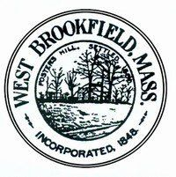**The West Brookfield Historical Commission,** members of the community, and The Trustees are pleased to present a Bicentennial Birthday Celebration honoring Lucy Stone.

We welcome all who join us in recognizing her accomplishments which are frequently overlooked. She was a leading force in the fight for Women's Rights and equality for all.

We would also like to extend a special welcome for those Stone and Blackwell family descendants who are able to join us.

We thank our Celebration Committee and we are grateful for the guidance of our Chairman Dan Hamilton over the past several months in planning this event.

It is the mission of the Historical Commission to identify, protect and educate the public on the historical assets of our town. Lucy Stone is a treasured local and national asset.

At the end of the day may we all be motivated as Lucy Stone was to "Make the world better."

Richard Rossman, Chairman

West Brookfield Historical Commission

Commission Officers:

Anne-Marie Nolan, Treasurer  
David Fitzgerald, Secretary

Members: Associate Member:

Ron Bullock Ben Bullock  
Louise Garwood  
Dan Hamilton  
Jessie Morrison

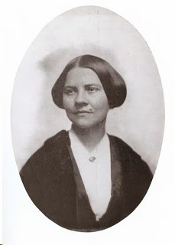

**Remembering Lucy Stone**

**August 11 & 12, 2018**

Described as an orator who “wins all who once hear the sound of her voice,” Lucy Stone was one of America’s most popular public speakers during the decade before the Civil War. Addressing audiences that numbered in the thousands, she was, in the words of Elizabeth Cady Stanton, “the first speaker who really stirred the nation’s heart on the subject of woman’s wrongs.”

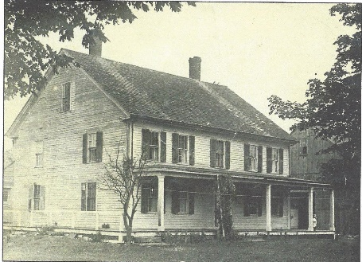Born August 13, 1818, on a farm in the central Massachusetts village of West Brookfield, Lucy Stone was influenced by the woman’s rights agitation that characterized the state’s antislavery movement under the leadership of William Lloyd Garrison. As an eighteen-year-old, she read accounts of the 1837 national convention of anti-slavery women, which affirmed women’s right to petition and repudiated social mores that forbade their involvement in public affairs. That same year she attended, as a spectator, the state convention of Congregational ministers, where she heard the first reading of the infamous pastoral letter that condemned women’s public speaking, and she resolved that if ever she had something to say in public, she would say it all the more because of this attempt to silence women. Lucy digested Sarah Grimke’s 1838 *Letters on the Equality of the Sexes* and emulated Abby Kelley’s insistence on speaking and voting in public meetings. And she deplored the rupture in the antislavery movement caused, in part, by one faction’s opposition to woman’s rights agitation within the movement. Sympathizing with the Garrisonian woman’s rights advocates, Lucy resolved to “help the cause along.”

Determined not to marry until unjust laws against wives were expunged, Lucy prepared for self-support by seeking the highest education she could get. After attending Mount Holyoke Female Seminary and several coeducational academies, she traveled to Ohio to attend Oberlin College—the only college that then admitted women.

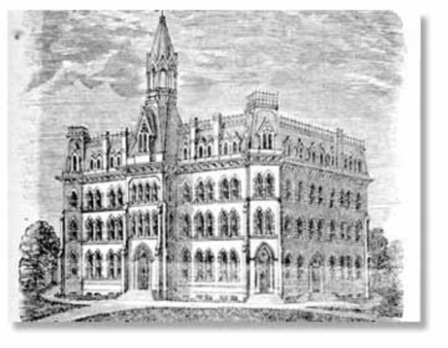It was at Oberlin that Lucy Stone decided to become a public speaker and woman's rights reformer. After graduating in August 1847, she delivered her first woman’s rights lecture, from the pulpit of her brother in Gardner, Massachusetts. The following year, after the Seneca Falls and Rochester woman’s rights conventions were held in New York, convention organizers asked her to lecture under their auspices. Although she accepted the invitation, the agency never materialized, so Stone spent three years as a lecturing agent for the Massachusetts Anti-Slavery Society. During that time she developed her speaking skill and blended woman’s rights and antislavery work: She addressed Pennsylvania’s first woman’s rights meeting; began conducting annual woman suffrage petitioning to the Massachusetts legislature; was invited, but declined, to address the Ohio legislature on behalf of woman suffrage petitioners; and spearheaded the calling of the first National Woman’s Rights Convention, in Worcester, Massachusetts, in 1850. Then, in 1851, she left her antislavery agency to strike out on her own as an independent itinerant lecturer.

## Heart and Soul of the Woman’s Rights Movement

Quickly gaining a reputation for eloquence and uncommon persuasive power, Stone attracted throngs while lecturing in eighteen states, the District of Columbia, and Ontario. Much sought after on the lyceum lecture circuit as well as at reform meetings, she was often the only woman on program rosters that included such popular male orators as Ralph Waldo Emerson, Horace Greeley, Charles Sumner, Henry Ward Beecher, and Thomas Star King.

### Not only the primary spokesperson of the woman’s rights movement, Lucy Stone was also its most visible leader. After the first National Woman's Rights Convention, she remained the driving force behind the national conventions that met annually throughout the following decade. She also remained the primary force behind suffrage petitioning. After sending her petitions to the Massachusetts legislature for four years, in 1853 she directed them to the state’s Constitutional Convention. Her hearing before that body made her the first person, male or female, to appeal for woman suffrage before an assembly of American lawmakers.

Arguing that the ballot was the means of achieving and protecting all other civil rights, Stone initiated multi-state petition efforts in 1854 and 1855, and in 1856, as a representative of the National Woman’s Rights Convention, she sent suffrage memorials to twenty-five state legislatures, two of which granted hearings. It was also Stone who compiled and printed most of the movement’s promotional literature, paying for much of it from her lecture proceeds and raising funds for the rest.

*“Lucy Stone with her usual energy has had a series of five tracts stereotyped, and has also a plan for prize stories and has raised money for these. Lucy is Queen of us all in this matter and delights the whole country from Maine to Kentucky. She is a household word down here on the Penobscot after one visit a year ago. You have no idea of the strength and power which have been developed in her; she is one of the great Providences in History.”*

*—Thomas Wentworth Higginson, December 1854*

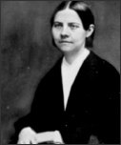There is no way of measuring the full impact of Stone’s influence, but numerous personal testimonials relate how she inspired women to knock on doors closed against them, and inspired men to help open those doors. In Maine, Stone influenced a number of young women to seek employment at a printing office and counting house, and the proprietors to hire them. She also inspired the town’s residents to rally behind a woman hired as Registrar of Deeds when critics sought her dismissal on grounds that it was unconstitutional for a woman to hold office. In Ohio, Stone’s words put down a strike among male printers protesting the hiring of women at a printing office. The young woman who led the first effort of women to gain admission to the University of Michigan, then the largest university in the land, attributed her inspiration to having heard Stone’s appeal for such action a few years earlier. Credited with inspiring the Massachusetts legislature’s 1855 passage of a married women’s property bill, a Kansas legislator asked Stone for a draft of an even more comprehensive law. The draft she provided, stripped of some of its more radical features, became law in Kansas in 1858.

Known nationally for such work and influence, the *New York Tribune* called Lucy Stone the “heart and soul” of the woman’s rights movement.

## Marriage, Motherhood, and Protests

Succumbing to two years of ardent wooing, Stone surrendered her early resolve not to marry and wed Henry B. Blackwell at her family home on May 1, 1855.

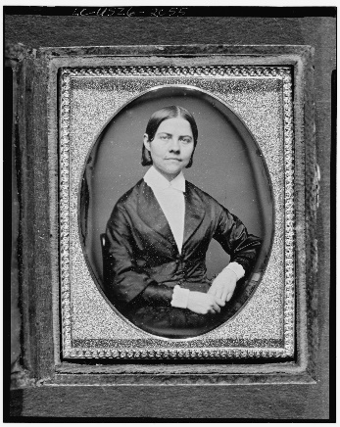

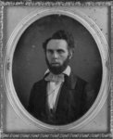 Blackwell convinced her that despite laws that gave husbands superior rights and relegated wives to a subjugated position, the two of them could create a marriage of equals. In preparation for their marriage, they entered what might be considered a private “prenuptial” agreement, which guaranteed Stone her personal and financial independence. As part of the wedding ceremony, Blackwell read a document the two of them had signed, protesting laws that treated wives unjustly. Widely publicized, their protest inspired other reform couples to include similar statements in their ceremonies, which became known as “woman’s rights weddings.”

In September 1857, Lucy Stone gave birth to a daughter, Alice Stone Blackwell. Four months later, having protested “taxation without representation” by returning a tax bill unpaid, she held her babe in her arms as household goods were sold at public auction to satisfy the tax and court costs. This protest, too, inspired followers. Over the following decade and beyond, women in several states waged a mini tax revolt, with one case ending up before the Massachusetts Supreme Court.

Lucy kept her own name when she married, assured by legal authorities that a wife’s assumption of her husband’s surname was a matter of custom rather than of law. But years later, when Massachusetts granted women the right to vote in school elections, Stone was notified that she would not be permitted to vote unless she added “Blackwell” to her name. This she refused to do. To Stone, a woman’s right to her autonomy and individual identity was more precious even than the right to vote.

**American Woman Suffrage Association**

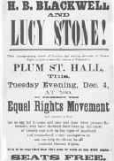

After the Civil War, agitation focused on winning woman suffrage. Stone was a leader of the American Equal Rights Association (AERA), which tried to link demands for black and woman suffrage under the same principles. When this joint strategy failed in several states and it became certain that Congress would pass a proposed Fifteenth Amendment guaranteeing suffrage to black males but not to women, Stone turned to winning woman suffrage separately. She founded the New Jersey State Woman Suffrage Association in 1867, helped found other state suffrage organizations the following year, and at the AERA’s 1868 annual meeting, presented petitions for a federal woman suffrage amendment—what she called a “Sixteenth Amendment.” In 1869, disagreement over whether the AERA should support or oppose ratification of the Fifteenth Amendment led to a schism and the formation of rival national woman suffrage organizations.

Stone helped found the American Woman Suffrage (AWSA), through which state and local suffrage organizations could coordinate their policies and work. As chair of its executive committee, she led the AWSA until 1890, when it merged with the National Woman Suffrage Association (NWSA), led by Susan B. Anthony and Elizabeth Cady Stanton. Contrary to traditional interpretation, the AWSA did not reject work for a federal amendment in favor of winning suffrage state by state. Rather, believing Congress would not pass a woman suffrage amendment until there was strong demand for one, the AWSA set about creating that demand—through organizing state and local suffrage societies, holding national conventions in large towns across the country, campaigning for suffrage amendments to state and territorial constitutions, lobbying for suffrage planks in the platforms of state and national political parties, and educating the public through suffrage meetings and literature. With increasingly ill health and a voice weakened during one of her strenuous campaigns, Stone gave up lecturing but continued to address suffrage meetings and aid suffrage campaigns across the land. For, with its body of state auxiliaries and affiliates, the AWSA was larger and more active than the NWSA until the mid-1880s, when temperance activists and a new generation of suffragists gravitated to it.

***Woman’s Journal***

One of the AWSA’s primary means of spreading woman suffrage ideas was its weekly newspaper, the *Woman’s Journal*, which Stone helped found in 1870. She quickly became the paper’s chief editor and, starting in the mid-seventies, Stone and her husband, and subsequently their daughter, produced the *Woman’s Journal* together. Not only the suffrage movement’s primary organ for over forty years, with readership and contributors throughout the United States as well as in many foreign countries, the *Woman’s Journal* chronicled the progress of woman suffrage throughout the world.



Lucy Stone died on October 18, 1893. A pioneer in death as in life, she was the first person in Massachusetts to be cremated. Her remains are at the Forest Hills Crematory in Jamaica Plain, Massachusetts, a suburb of Boston.

## Forgotten Heroine

## 

Most of what future generations have learned about the woman’s rights and woman suffrage movements has been based on the classic *History of Woman Suffrage*, written by leaders of the rival NWSA while the movement was still bitterly separated. Because Stone refused to cooperate with its editors, they decided, as Elizabeth Cady Stanton explained, “to say of her what History demanded and no more.” What they determined to be the demands of history resulted in a resource that Gerda Lerner, one of the founders of women’s history as an academic study, described as both “downplaying the role of many activists and antecedent activists in favor of stressing the leadership of a few women,” and “factionally biased in its downplaying of the role of the women who in 1869 split with Stanton and Anthony, a distortion which is particularly striking in regard to the role of Lucy Stone.” Stone could not have known that Stanton and Anthony’s *History of Woman Suffrage* would be accepted as an authoritative primary source by historians for more than a century. But even a decade after its publication, as younger suffragists replaced Stone’s contemporaries and memory of her contributions and influence faded, she found solace in lines from a Scottish hymnist:

I need not be missed, if another succeed me,

To reap down those fields which in spring I have sown;

He who plowed and who sowed is not missed by the reaper,

He is only remembered by what he has done.

Not myself, but the truth that in life I have spoken,

No, not myself, but the seed I have sown,

Shall pass on to ages, all about me forgotten,

Save the truth I have spoken, the things I have done

Written by Joelle Million

for the West Brookfield Historical Commission’s Lucy Stone Bicentennial Celebration, August 2018

**The West Brookfield Historical Commission**



**What are we?**

A Historical Society? No!

We are a seven-member board appointed by the Board of Selectmen.

**What is the purpose of a Local Historical Commission?**

The local Historical Commission is the agency responsible for identifying and recording the historic assets of its community and for developing and implementing a program for their recognition and preservation.

**What is our responsibility?**

Our primary responsibility is the inventory of historic assets which provides the basis for all preservation planning in the community. The Commission cooperates with other municipal agencies such as the Planning Board and the Conservation Commission to ensure that the goals of historic preservation are considered in planning for the future development of the community.

**How do we differ from a Historical Society?**

A Historical Society is a private organization formed to collect and preserve artifacts of local historical interest, which may serve to illuminate and illustrate the history of a town; preserve historical sites and landmarks and promote the study of history.

**What have we accomplished?**

National Historic Register Listings

* Jedediah Foster Homesite (2013)
* Center Historic District Expansion (2006)
* Old Indian Cemetery (2006)
* Wickaboag Valley Historic District (2000)
* West Brookfield Center Historic District (1990)
* Salem Cross Inn – (1975)
* The 1767 Franklin Milestone Markers (1971)

Other Recent Projects

* Nominated ‘Lucy Stone Homesite’ to the National Historic Register (2018)
* Awarded contract for nomination of The Methodist Cemetery on Lyon Road to the National Register of Historic Places (2018)
* Published a Guide to that portion of the “Old Bay Path Indian Trail” that crossed through the Quaboag Plantation (2018)
* Contributed to preservation of Pynchon Grist Mill with the East Quabbin Land Trust (2014)
* Published “A History of West Brookfield 1675-1990)"by Jeffrey H. Fiske (2009)
* Purchased Elm Trees for the Town Common (2009)
* Funded inventory of Historical Collections in Merriam-Gilbert Library (2009)
* Purchased and installed Franklin Mile Marker Signs (2009)

Ongoing Projects

* Award annual West Brookfield Historical Commission Scholarship @ the Quaboag Regional Middle and High School
* Fund Gravestone Conservation effort at the Old Indian Cemetery (2013 – present)
* Co-Sponsor historical programs at the library
* Co-Sponsor “Asparagus and Flower Festival” on the Town Common

Our projects have been supported by the generosity of the Town of West Brookfield and gifts from the J. Irving England and Jane L. England Charitable Trust.

**Goals for the future**

* Nomination of the Rock House Reservation to the National Historic Register

**How can we help you?**

We maintain research files and a small library that contains information about the history, townspeople, places, and events. Maps, survey forms and photographs are available for study.

**Meetings**

The West Brookfield Historical Commission meets every first Wednesday of the month, September to June, at 7:00 PM in the Commission office in the Town Hall. All Meetings are open to the public.

**How can you help?**

In an effort to expand the holdings and resources of the Historical Commission’s library, the West Brookfield Historical Commission would like to invite anyone with a heritage in West Brookfield to submit a copy of their family history to the library. These family histories do not have to be professionally published works. They can include small folder editions, essays, or recollections that have been passed down through the family. Copies of any other collections that might be of historical or genealogical value such as newspaper clippings, news articles, old photograph collections, journals, etc. are also welcomed.

**Contact us –**

West Brookfield Historical Commission

Town Hall

P.O. Box 372

West Brookfield, MA 01585

Phone: 508-867-1421

Fax: 508-867-1401

Email: [info@westbrookfield.org](mailto:info@westbrookfield.org)

Visit our website:

www.westbrookfield.org

Community

This celebration is made more memorable and encompassing by the participation of members of our community. Organizations, businesses, and volunteers have all given generously to this event.

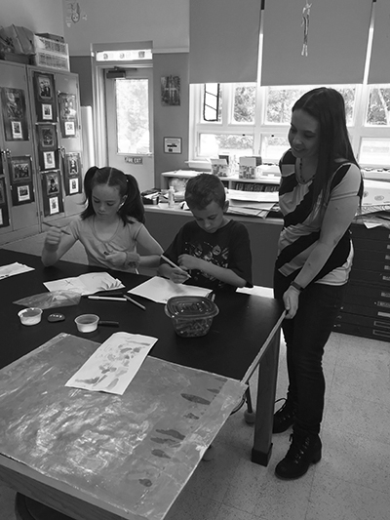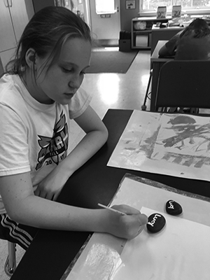Of special note are the contributions by the students of the West Brookfield Elementary School, who, under the guidance of art teacher Kelly Mundell, created the artwork, birthday cards, and “Lucy-Stones” visible in the Great Hall.

The Merriam-Gilbert Library initiated art and poetry contests, book club choices, special displays, and a trivia contest to honor the memory of Lucy Stone.

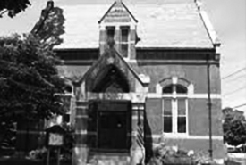

Touching the lives of young people with the story of Lucy Stone is an inspirational example of fulfilling her last words, “Make the World Better.”

**Events Schedule – Saturday, August 11th**

**8:30 a.m. to 12:00 p.m.**

**THREE-SITE TOUR**

**Quaboag Historical Society Museum**

Begin with a tour of the Quaboag Historical Society Museum. Then travel by bus to the Lucy Stone Home Site and to the Rock House Reservation, two of the many special places cared for by The Trustees. Narration by renowned Stone biographer Joelle Million. (The bus tour is not suitable for wheelchair access and will involve outdoor walking, up to a quarter mile, on a slight incline.) Capacity: 80

**2:00 p.m. to 4:00 p.m.**

**BIRTHDAY CELEBRATION SUFFRAGIST TEA**

**Great Hall in the Town Hall, 2 East Main Street**

Birthday Celebration Suffragist Tea with a selection of refreshments, a one-of-a kind cake by June’s Bakeshop, costumed hostesses, a display of the timeline of the women’s rights movement, and artistic contributions from local elementary school children. Guest speakers will include Honorable State Senator Anne M. Gobi, State Senator Stephen M. Brewer, and keynote speaker, Regina M. Edmonds, Ph.D., Professor Emerita of Psychology and former Director of Women’s Studies at Assumption College. With live period music by strolling master musician Rob Lyon, the afternoon is sure to be full of energy from the townspeople and guests honoring Lucy Stone. Bus shuttle service will be available from the Quaboag Historical Society Museum parking area. Capacity: 152

**Saturday, August 11, 2018 7:30 p.m. to 9:00 p.m.**

**CONCERT OF PERIOD SONGS**

**Congregational Church on the Common, 36 N. Main St**.

Concert of period songs featuring the well-known Old Sturbridge Village Singers. The Stone family attended services in an earlier building. Capacity: 138

**Events Schedule – Sunday, August 12th**

**2:00 p.m. to 4:15 p.m.**

**I NOW PRONOUNCE YOU LUCY STONE**

(There will be a 15-minute intermission.)

**A CONCERT OF PERIOD MUSIC**

**Congregational Church on the Common, 36 N. Main St.**

I Now Pronounce You Lucy Stone, a powerful one- woman show featuring Judith Kalaora of New England’s History at Play, followed by a concert of period instrumental music with violinist Samantha Gillogly and pianist Virginia Bailey. Capacity: 138

**7:30 p.m. to 9:00 p.m.**

**ROUND TABLE PANEL DISCUSSION**

Great Hall in the Town Hall, West Brookﬁeld

A round table panel discussion titled Lucy Stone, Where Do We Go From Here? will be moderated by Deborah Becker, WBUR Radio Host and Senior Correspondent, and feature Senator Anne M. Gobi, Dr. Regina M. Edmonds, Author Joelle Million, Dr. R. Vivian Acosta, Dr. Linda Jean Carpenter, and Samantha Gillogly, along with other guests and audience participation. This event will be videotaped for future use. Capacity: 250

*“If, while I hear the shriek of the slave mother robbed of her little ones, I do not open my mouth for the dumb, am I not guilty? Or should I go from house to house to do it, when I could tell so many more in less time, if they should be gathered in one place? You would not object or think it wrong, for a man to plead the cause of the suffering and the outcast; and surely the moral character of the act is not changed because it is done by a woman.”*

Lucy Stone

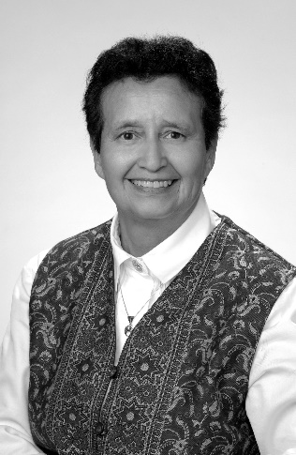**R. Vivian Acosta, Ph.D.**

(*Panelist – Round Table Discussion*)

Vivian Acosta, Professor Emerita of Brooklyn College of the City University of New York, is a past president of the National Association for Girls and Women in Sport.

At Brooklyn College Vivian served in many capacities including teacher, coach, athletics administrator and deputy chairperson of the graduate program. Over her thirty-two years at Brooklyn College her teaching program included courses in teacher preparation, sociology of sport, athletics administration, officiating, and a very diverse list of activity classes.

Her years of intercollegiate coaching included leading teams such as basketball, volleyball, field hockey, softball and men’s and women’s badminton. Her athletic administrative experiences began even while she was still in school; she served as acting women’s athletic director at Brigham Young University while also completing her masterʼs degree. This early and daunting administrative responsibility at BYU gave her courage and perspective from which to draw as she became the womenʼs athletics director at Brooklyn College, a program which included seventeen varsity and junior varsity teams, a handful of club sports and an extensive intramural program.

As deputy chairperson of the graduate program at Brooklyn College, she administered programs in teacher education, sports management, exercise science and several smaller programs.

In many ways, her teaching, coaching and administrative career reflects the diversity and complexity of responsibilities typically experienced by many who have careers in sport.

Service is another trait characterizing Vivian. She has served her institution in many ways and Brooklyn College recognized her multidimensional contributions by granting her the coveted Tow Award. Vivian has given numerous presentations at local, regional, national and international fora.

Service to groups beyond those focusing on women in sport includes, among others, service as a member of the AAHPERD Board of Governors, founding board member of A Very Special Place (an agency serving the needs of the adult developmentally disabled individual), and a continuing commitment to serve wherever needed in her church and community.

Vivianʼs service extends to publications and research. She has published numerous articles and books on a variety of topics, many centered on equity issues. Her jointly authored “Acosta-Carpenter” national, longitudinal study on the status of women in intercollegiate sports now in its 37th year is perhaps the most well-known of her research efforts.

Vivian holds an Associate of Arts degree from Los Angeles City College, a B.S. and M.S. from Brigham Young University and the Ph.D. degree from the University of Southern California. The range of certifications and awards received by Vivian extends the full breadth of the profession from ʻnationalʼ officiating ratings on one hand to recognitions such as both the Honor Award and the Lifetime Achievement Award from the National Association of Collegiate Women Athletic Administrators, the Billie Jean King Award from the Womenʼs Sports Foundation, and the Honor Award and several Presidential Awards from the National Association for Girls and Women in Sport on the other.

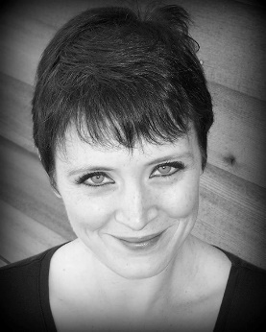**Virginia Bailey**

(*Musician – Concert of Period Music*)

Virginia Bailey is the Director of Instrumental Music at Auburn High School and the Music Director for the First Congregational Church in West Brookfield. She received her Bachelor of Music degree from UMass Amherst in Music Education with concentrations in piano, horn, and voice and her Master of Music degree from UConn Storrs in Music Education.

An active freelance musician, she is in demand as an accompanist for several regional theater, school, and choral groups as well as area churches. She continues her horn performance with the Brookfield Brass Quintet, Bay State Winds, Valley Winds and local pit orchestras. Equally at home in both Instrumental and Vocal Music, she is also a member of the Tanglewood Festival Chorus (the chorus in residency with the Boston Symphony Orchestra and Boston Pops), Novi Cantori in Longmeadow, MA, and Auriel Camerata in Schenectady, NY (professional chamber choirs).

She also performed on the Final Fantasy XV soundtrack. With the TFC she has performed with such prestigious conductors as Andris Nelsons, James Burton, John Oliver, and Keith Lockhart at venues including Symphony Hall in Boston, Tanglewood in Lenox, MA, and Carnegie Hall in New York. In her free time, you can find her composing electronic music for film and video games and programming synthesizers for musical theater.

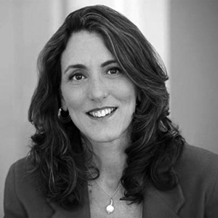**Deborah Becker**

(*Moderator, Round Table Discussion*)

Deborah Becker is a senior correspondent and host at WBUR. Her reporting focuses on mental health, criminal justice and education.

Deb is also a substitute host on several WBUR programs and helps produce and report for various WBUR special projects. Deb also worked on the launch of WRNI, Rhode Island's NPR News Station, where she served as Morning Edition host and host of the weekly show "Focus Rhode Island."

Before coming to WBUR, Deb worked at Monitor Radio, the broadcast arm of The Christian Science Monitor newspaper. She also worked at several Boston area radio stations. Deb has received numerous awards for her hosting, newscasts, reporting and investigative reporting from the Radio Television Digital News Association (RTNDA), Public Radio News Directors Incorporated, National Education Writers Association, Associated Press, Corporation for Public Broadcasting, National Alliance on Mental Illness, Parent/Professional Advocacy League and United Press International. She has also completed several fellowships on addiction, mental health, juvenile justice and journalism and the law.

Deb studied journalism at St. Bonaventure University. She lives with her family in central Massachusetts.

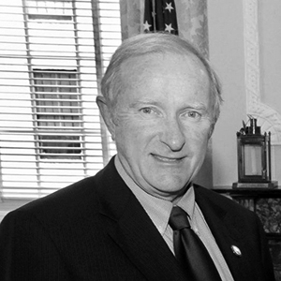**Stephen Brewer**

*(Speaker – Suffragist Tea / Birthday Celebration)*

Stephen Brewer was born on February 10, 1948 in Worcester, MA. He was raised in the town of Barre, Massachusetts. He received his B.A. from the University of Massachusetts Amherst in 1971, and his M.A. from Assumption College in 1974.

Senator Brewer started his political career on the Barre Board of Selectmen, where he served from 1977 to 1984, eventually becoming the board's chairman. He also worked as an aide to state Senator Robert D. Wetmore from 1980 to 1988. He became a member of the Massachusetts House of Representatives in 1989 and moved onto the Massachusetts Senate in 1997, where he served until his retirement in January 2015.

In the state Senate he represented the Worcester, Hampden, Hampshire, and Franklin District. As the Senate Chair for the Joint Committee on Veterans and Federal Affairs, Brewer was instrumental in the passing of the Welcome Home Bill, a comprehensive package for recent combat veterans to come home to as they transition back to civilian life. He also chaired the Senate Committee on Bills in the Third Reading and served as Vice-Chair of the Joint Public Safety and Homeland Security Committee.

Senator Stephen Brewer retired from the Senate at the end of his term in January 2015.

He is an ardent supporter of the community and history and has been honored for his contributions to both.

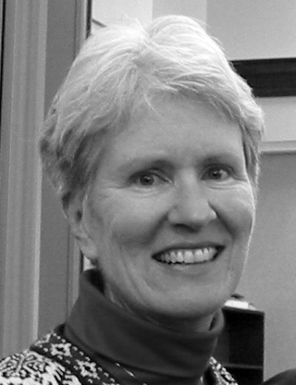**Linda Jean Carpenter, Ph.D., J.D.**

(*Panelist – Round Table Discussion*)

Linda Jean Carpenter, Professor Emerita at Brooklyn College, is also an attorney, a member of the New York State Bar and the United States Supreme Court Bar. Much of her current work focuses on legal issues, primarily gender equity, however her more than three decades at Brooklyn College included a variety of teaching topics, campus governance service and efforts as the charter gymnastics coach (all winning seasons).

Her educational background includes a B.S. and M.S. from Brigham Young University, a Ph.D. from the University of Southern California and a J.D. from Fordham University School of Law. Her major research topics, with co-researcher R. Vivian Acosta, center around a longitudinal national survey on the status of women in intercollegiate athletics (now in its 37th year) as well as job stasis among senior women administrators in athletics and perceived causes for the declining representation of female leaders in sports. She is the author or co-author of eleven books, ten of which are academic in focus. The three most recent books are Title IX, co-authored with Vivian Acosta, Legal Concepts in Sport - A Primer, and is a co-author of Sport, Physical Activity, and the Law. She has also published over 80 articles and has presented at over 180 national, regional and local conferences. She has received about 40 grants.

Linda has been honored with the Lifetime Achievement Award from NACWAA (National Association of Collegiate Women Athletic Administrators) as well as the association’s Honor Award. From NAGWS (National Association for Girls and Women in Sport) she has received the Rachel Bryant Award as well as two Presidential Honor Awards. Among her other awards are the Billie Jean King Award from WSF (Women’s Sports Foundation), the Outstanding Nonprofit Lawyers Award for Outstanding Academic from the ABA (American Bar Association), the Leadership Award from SRLA (Sport and Recreation Law Association), the Distinguished Scholar Award from the School and Community Safety Society of America, the J.B. Nash Award from AALR (American Association for Leisure and Recreation) and was one of two selected for the Honored Alumni - 100th Homecoming by Brigham Young University.

She is also the recipient of the ***2010 Lucy Stone Award***, an award named after a prominent American abolitionist and suffragist who was a vocal advocate and organizer promoting rights for women in the 1800s.

Linda contributed significantly to governance and community service at Brooklyn

College as an elected member of the Policy Council, Faculty Council and its Steering Committee, and as chair of both the Undergraduate and Graduate curriculum and Degree Requirements college wide committees and the Committee on College Integrity.

She serves on several advisory boards in her community including a nine-year effort on the publicly elected Library Board of Trustees, A Very Special Place, Inc. (serves adult developmentally disabled community members in New York) and is active in her church and community.

*“We believe that personal independence and equal human rights can never be forfeited, except for crime; that marriage should be an equal and permanent partnership, and so recognized by law; that until it is so recognized, married partners should provide against the radical injustice of present laws, by every means in their power...”*

Lucy Stone

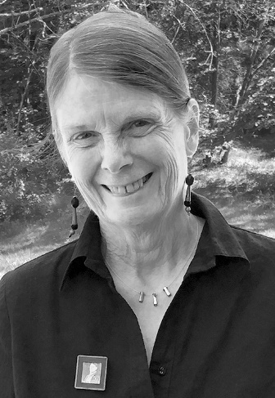**Regina M. Edmonds, Ph.D.**

(*Keynote Speaker – Suffragist Tea/Birthday Celebration, Panelist – Round Table Discussion)*

Professor Emerita of Psychology

Former Director of Women’s Studies

Assumption College

Dr. Edmonds is a licensed clinician who taught psychology at Assumption College for thirty-five years. One central goal of her teaching was to encourage students to approach every human being with empathy, generosity, and compassion, using the lens of understanding their study of psychology provided. Her research focuses on the challenges faced by women in their demanding roles as mothers, wives, and workers and her clinical work moved her to dedicate herself to supporting women affected by all forms of physical and psychological trauma.

In 2000, she became the director of Assumption’s Women’s Studies Program and helped the program grow by encouraging the expansion of course offerings and by blending academic work with innovative co-curricular activities including dance performances, films, and lectures by playwrights, poets, and human rights activists. As director, she frequently taught the program’s signature course, *Images of Women in American Popular Culture*, which allowed her to learn much about the history of the women’s movement in America, including the significant contributions of Lucy Stone.

While passionate about promoting women’s rights in the United States, Dr. Edmonds also believes it is vitally important to understand the challenges women face globally. Therefore, she worked to internationalize Assumption’s Women’s Studies curriculum by developing, with colleagues, the course *Women of the World* and then creating a Passport to the World of Women co-curricular initiative. Her goal was to encourage students to discover universal elements of human experience across cultures while at the same time learning to appreciate the enormous beauty found in the rich diversity among the people of our world.

Dr. Edmonds is also an active member of the Worcester Women’s History Project (WWHP) and is particularly interested in integrating into the WWHP’s archives the stories of refugee women who have enriched the Worcester community.

*“I know, Mother, you feel badly and that you would prefer to have me take some other course, if I could in conscience. Yet, Mother, I know you too well to suppose that you would wish me to turn away from what I think is my duty. I surely would not be a public speaker if I sought a life of ease, for it will be a most laborious one; nor would I do it for the sake of honor, for I know that I shall be disesteemed, even hated, by some who are now my friends, or who profess to be. Neither would I do it if I sought wealth, because I could secure it with far more ease and worldly honor by being a teacher. If I would be true to myself, true to my Heavenly Father, I must pursue that course of conduct which, to me, appears best calculated to promote the highest good of the world.”*

Lucy Stone

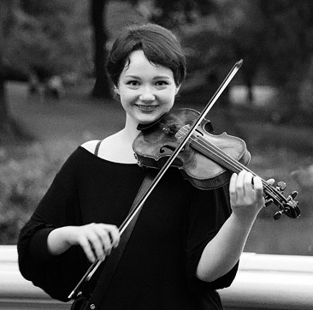**Samantha Gillogly**

(*Musician – Concert of Period Music, Panelist – Round Table Discussion)*

Born in Los Angeles, Samantha Gillogly began her musical training in violin at age six on the island of Martha's Vineyard. She has studied with numerous renowned performers and educators, including Russian national prizewinner Lilia Muchnik, jazz artist David Eure, and Boston Symphony concertmaster Malcolm Lowe at New England Conservatory. She holds a Bachelor’s in Performance, summa cum laude, from Berklee College of Music in Boston.

Fluent in the western classical tradition, Samantha also loves the freedom and creativity of improvisation, and is an avid fan and performer of Celtic, Middle-eastern, Gypsy, and other global styles. From 2007-2011 she was the principal violist of the Boston Civic Symphony, and in 2008 was a touring member of the Tim Janis Ensemble. In 2009, she participated in the innovative multimedia Youtube Symphony Orchestra at Carnegie Hall under the direction of Michael Tilson-Thomas.

Formerly a resident of West Brookfield, Samantha has performed at various town events including White Christmas and the Asparagus Festival and has put on recitals at the Great Hall to raise funds for the Merriam-Gilbert Public Library. Now based in New York City, she is first violinist and artistic director of pop-culture quartet Spellbound Strings and is a member of the world music trio Bazaar and the spiritual/social-justice folk-rock band REVIVAL.

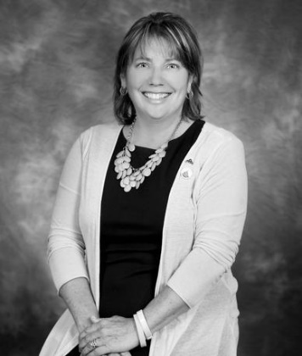**Senator Anne Gobi**

(*Speaker – Suffragist Tea /Birthday Celebration, Panelist – Round Table Discussion*)

Senator Gobi was born and raised in Spencer and still lives there today. She attended David Prouty High School and studied at Worcester State College. She began work as a teacher at Leicester High School, while attending Massachusetts School of Law in pursuit of her Law Degree.

​A member of the Spencer Democratic Town Committee since 1998, she was elected to serve as the State Representative for the 5th Worcester District. She was a member of the Massachusetts House of Representatives for 14 years, serving on multiple committees including the Joint Committee on Environment, Natural Resources and Agriculture, of which she was co-Chair.

Anne was elected as State Senator in 2014 and has continued her work for the entire Worcester, Hampden, Hampshire and Middlesex district.

For the last several years Sen. Gobi has ridden in the Pan-Mass Challenge and regularly contributes to various charities and charitable organizations.

*“I believe that the influence of woman will save the country before every other power.”*

Lucy Stone

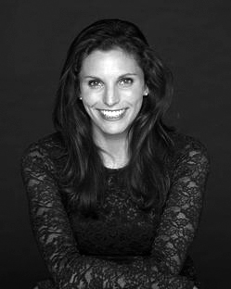**JUDITH KALAORA**

*“I Now Pronounce You Lucy Stone”*

Founder ~ Artistic Director ~ Principal Performer

History at Play

Judith is a professional educator, actress, and living historian. She graduated Magna cum Laude from Syracuse University and holds a Bachelor of Fine Arts in Acting, along with a Bachelor of Arts in Spanish Language and Culture. She attended the Globe Education Program of Shakespeare's Globe Theatre in London, England.

Judith founded **History At Play**™ in 2010 to provide educational entertainment, chronicling the lives of influential and often forgotten women. Judith researches, writes, produces, and performs.

Visit [http://www.judithkalaora.com](http://www.judithkalaora.com/) to learn more.

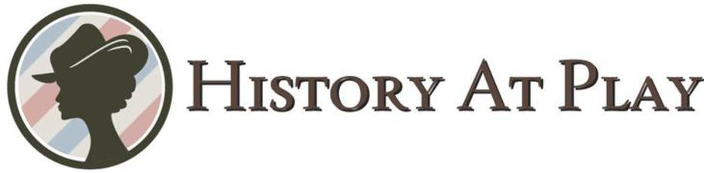

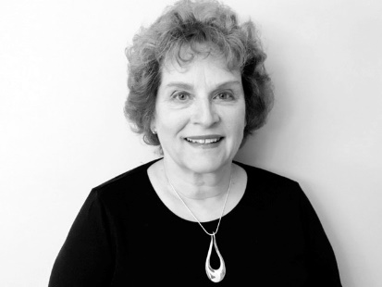**Joelle Million**

(*Speaker - Three Site Tour, Panelist - Round Table Discussion*)

Joelle Million is a scholar of both Lucy Stone and the Blackwell family into which Stone married. Her 1998 award-winning master's thesis, *"'What History Demanded': Lucy Stone and the Stanton-Anthony Tradition of the Antebellum Woman’s Rights Movement,"* explored Stone’s role not only as a founder of the movement that became the woman suffrage movement, but also as its primary organizer and spokesperson.

Continuing the analysis, Million’s 2003 book *Woman’s Voice, Woman’s Place: Lucy Stone and the Birth of the Woman’s Rights Movement*, examined the influence of such contemporaneous movements as Garrisonian anti-slavery, Fourierism, dress reform, temperance, and marriage reform in shaping both Stone’s egalitarian ideology and the movement’s agenda. Million is currently working on a biography of Stone’s husband, Henry Browne Blackwell, which will include a study of the American Woman Suffrage Association, which they led.

Former residents of the Midwest, Joelle and her husband, historian Johannes Postma, have lived in the Springfield area for the past seventeen years.

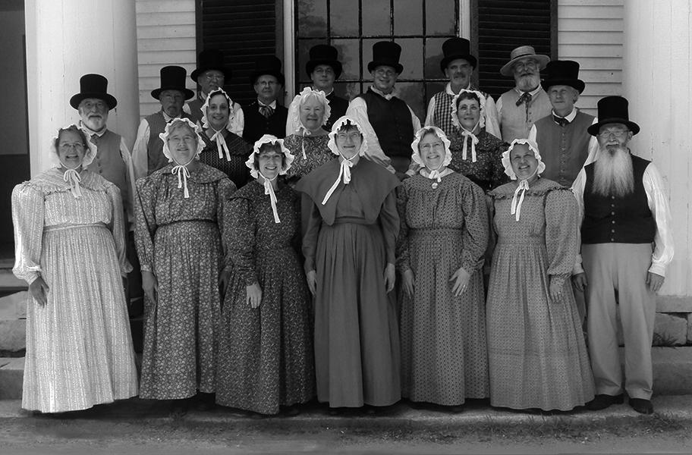**The Old Sturbridge Village Singers**

The Old Sturbridge Village Singers is an all-volunteer group that formed in 2002. We perform one or two Saturdays each month in the Meetinghouse at Old Sturbridge Village. We also perform a program of carols for the Old Sturbridge Village “*Christmas by Candlelight*” Celebration every Sunday evening in the month of December.

In the past 16 years, nearly 100 people have participated in the program. Our current number of singers is 25. They hail from Central and Western Massachusetts and North Central Connecticut.

Our repertoire consists of music that would have been familiar to New Englanders in the first part of the 19th Century. We sing hymns, patriotic pieces, popular music and folk songs. Most of our music is performed a cappella in four-part harmony as was the custom. Some of our folk-songs are accompanied by musicians playing dulcimer, guitar, banjo and recorder.

The Old Sturbridge Village Singers is always looking for musical talent. In the past, in addition to singers, we have been joined by organists, violinists, and pianists. Anyone who is interested can contact Kim Adams, Volunteer Coordinator for Old Sturbridge Village, at kadams@osv.org.

**The Lucy Stone Bicentennial Celebration**

**was made possible by the generosity of the following**

**Donors, Contributors, and Volunteers:**

The J. Irving England and Jane L. England Charitable Trust

The Trustees of Reservations

Barbara J. Erickson, President & CEO

Joanna Ballantine, Vice President, Western Region

Josh Hasenfus, Superintendent, Central Management Unit

The Quaboag Historical Society

Amy Dugas & Ed Londergan, Co-Presidents

Country Bank Gavitt Wire Cable Co. Inc Hannaford Brothers Co. Sherman Oil Company

Community Emergency Response Team

Pam Bobay of Worcester Women's History Project ~ Bernie Bouvier of Bouvier Bernard Painting Co. ~ Jane DeLuca of Dragonfly Farm ~ Rebecca Fay of Worcester Art & Frame ~ June Glidden of June’s Bakeshop ~ Judith Kalaora of History at Play ~ Our Lady of the Sacred Heart Parish ~ John McCarthy of J.P. McCarthy & Sons ~ Kelly Mundell, Art Teacher & Students of the West Brookfield Elementary School ~ Nancy Salem of Salem Cross Inn ~ The Old Sturbridge Village Singers ~ Johanna Swain of the Town of West Brookfield ~ George Whitefield Methodist Church

R. Vivian Acosta Holly Garceau

Virginia Bailey Samantha Gillogly

Deborah Becker Jane Higgins

Beth Blozie Bonnie Jean Holske

Charlotte Boos Bill Jankins

Julie Bullock Beverly Kenniston

Dave Cameron Ruth Lyon

Linda Carpenter Rob Lyon

Pam Christiansen Joelle Million

Kathy Collings Barbara Rossman

Regina Edmonds Yvette Thurber

Karli Epstein Madelyn Tivnan

**With special thanks to:**

U.S. Senator Elizabeth Warren

Governor Charlie Baker

Senator Anne Gobi

Senator Stephen Brewer

Representative Todd Smola

Representative Donald Berthiaume

And, to Moira Hickey of Scotland, who wrote to the Commission last December and asked if we had any plans. Welcome, and thank you.

Lucy Stone and Abby Kelley Foster:

Finding Strength and Inspiration in Friendship

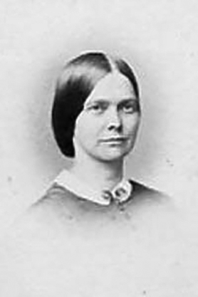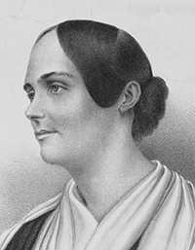As you probably know Lucy Stone devoted her life to the dual goals of abolishing slavery and enhancing the rights of women. She was known to be a most eloquent orator who at times moved audiences to tears as she recounted the horrors enslaved people faced and she also broke social barriers by traveling and speaking about the rights of women on her own without the accompaniment of her husband or other male family members. She even spoke to “promiscuous audiences” which meant at the time that both men and women were members of the audience. How shocking!

Lucy was also one of the organizers of the first National Woman’s Rights Convention which was held in Worcester, MA in 1850, two years after the more regional women’s rights meeting held in Seneca Falls, NY. In fact, it was a report on Lucy Stone’s stirring speech at the Worcester Convention that brought Susan B. Anthony into the struggle for women’s rights.

Knowing that Lucy was very much influenced by another important woman activist of the time, Abby Kelley of Worcester, MA, I decided to talk with Lynne McKenney Lydick who enacts the life of Abby Kelley in a play called *Yours for Humanity – Abby*. I thought it would be fascinating to view the work for women’s rights through the lens of the deep and abiding friendship that existed between these two remarkable women. Lynne told me that Lucy first heard Abby speak in 1842 in what is now West Brookfield and that this encounter had a profound effect on Lucy. Even at that early date Abby encouraged Lucy to participate in any way she might in the abolitionist movement. In 1843, shortly after this important encounter, Lucy went to Oberlin College and graduated in 1847, earning for herself not only a diploma but the honor of being the first woman in Massachusetts to have completed college. During her time at Oberlin, Lucy became more and more active in the abolitionist movement and was thrilled when the now Abby Kelley Foster and her husband Stephen Foster spoke in Oberlin. In a moving letter Lucy told Abby, “I wish I could tell you how much good I received from your visit here. My heart dances gaily at the remembrance – it will be long before I shall be so cheered again.”

Upon graduation from Oberlin College, Lucy returned to West Brookfield and continued to work as a teacher in local schools as she had done before college, but the idea of participating in the effort to abolish slavery was foremost in her mind. Once again it was Abby who saw in Lucy great potential and 1848 Abby directly helped Lucy acquire her first paid position as a lecturer for the Massachusetts Anti-Slavery Society. Lucy’s experiences on the lecture circuit and the discrimination she encountered as a woman speaker prompted her lifelong desire to blend together into one large movement the rights of everyone, including women. And the rest is history!!!

Lucy’s love and respect for Abby continued even when she disagreed with her and in passionate letters between the two, Lucy felt free enough to express her belief that Abby was on the wrong side of the question of whether the voting rights of former slaves and those of women should be separated or remain integrated. She wrote to Abby saying, “The tears are in my eyes and a wail goes through my heart akin to that which I should feel, if I saw my little daughter drowning with no power to help.” Despite this heartfelt disagreement, Lucy concluded one of these difficult letters to Abby with the words, “a kiss for the hem of your garment.”

Despite their very different styles of oration and the strategies they employed to achieve change Lucy and Abby remained friends and confidants until Abby’s death in 1887.Lucy spoke at Abby’s funeral saying, “The world of women owe her a debt which they can never pay. The movement for equal rights of women began directly and emphatically with her” and later Lucy eulogized her in the *Woman’s Journal* stating “Abby Kelley earned for us all the right of free speech.” While seven years younger than Abby, there is no doubt that the movement for universal equality can definitely be attributed to Lucy as much as to Abby and that the lives of all of us have been made better by their lifelong commitment to justice and equality.

I know for me that it has been my deep friendships with women which have sustained me in difficult times and which have increased my joy in times of great happiness. I think it was the same for Lucy and Abby and their friendship is just one more beautiful thing to honor as we celebrate the 200th birthday of the remarkable Lucy Stone.

Written by

Dr. Regina M. Edmonds

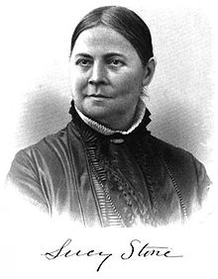

“Make the World Better.”

Lucy Stone

Presented by

The West Brookfield Historical Commission

With the community

And the Support of the Trustees